**Batch: IAI-2 Experiment Number: 7**

**Roll Number: 16010422234 Name: Chandana Ramesh Galgali**

**______________________________________________________________________________**

**Aim of the Experiment:** Study of Netica Software (free version) and use of it to build a small Bayesian Network.

**Program/Steps:**

1. Consider the Bayesian Network Diagram given below containing six random variables: "Burglary", "Earthquake", "Alarm", "JohnCalls", “ MaryCalls” and “Radio Announcement”

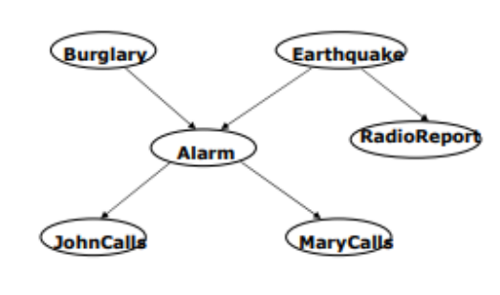

In this, "Burglary" and "Earthquake" are independent, and "Burglary" and "Radio Announcement" are independent given "Earthquake." This is to say that there is no event that affects both burglaries and earthquakes.

As well, "Burglary" and "Radio Announcements" are independent given "Earthquake" - meaning that while a radio announcement might result from an earthquake, it will not result as a repercussion from a burglary.

2. Create a Bayesian Network using Netica (free version) and explore the functions of Netica on the created network.

______________________________________________________________________________

**Output/Result:**

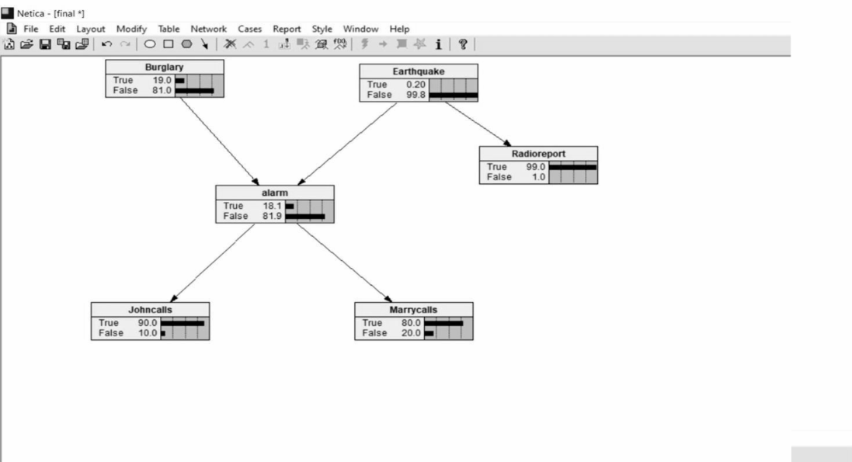

**______________________________________________________________________________**

**Post-Lab Questions:**

**Q1. List the features of Netica.**

**Ans:** Netica offers a wide range of features for working with Bayesian networks, including:

* Construction of Bayesian networks and decision networks.
* Definition of conditional probability tables (CPTs) for nodes.
* Updating beliefs with new evidence (belief updating).
* Sensitivity analysis and decision analysis tools.
* APIs for integration with various programming languages.
* Graphical user interface for easy visualization and manipulation of networks.

**Q2. State the following statements with respect to the diagrams are true or false and Justify your answer.**

1. **JohnCalls is independent of Burglary, given Alarm.**

**Ans:** True. Given the alarm's state, John's likelihood of calling is determined by the alarm and not directly by the burglary. The alarm mediates the effect of the burglary on John's call.

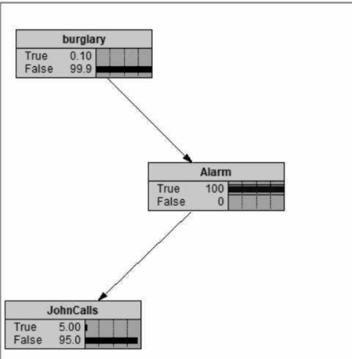

1. **Burglary is independent of Earthquake (not knowing Alarm) but Burglary and Earthquake become dependent, given Alarm.**

**Ans:** False. Burglary and Earthquake are always independent of each other, as their occurrence does not influence the other. The introduction of the Alarm doesn't create a dependency between Burglary and Earthquake; it only makes their individual effects on the Alarm observable.

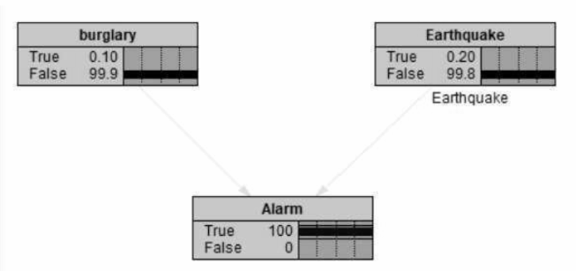

1. **MaryCalls is independent of JohnCalls, given Alarm.**

**Ans:** True. Mary's decision to call is influenced by the alarm, independently of John's decision to call. Their decisions are modeled as dependent only on the state of the alarm, not on each other.

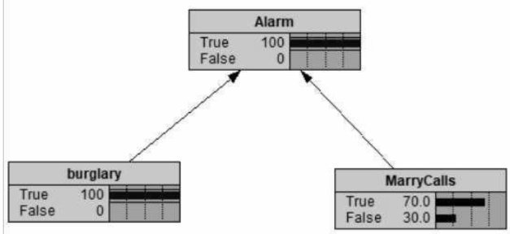

**______________________________________________________________________________**

**Outcomes: Comprehend problems with uncertainty, formalize the problem and understand how solutions are found.**

**Conclusion (Based on the Results and outcomes achieved):**

By creating and analyzing a Bayesian network in Netica, we can understand complex dependencies and independencies between various events. This experiment helps in understanding how Bayesian networks can be a powerful tool for reasoning under uncertainty, providing a structured way to incorporate evidence and update beliefs accordingly. Through the creation and manipulation of such networks in Netica, we gain hands-on experience with concepts of probability, dependence, and decision-making in uncertain environments, aligning with the outcomes and objectives set for this experiment.

**References:**

1. Stuart Russell and Peter Norvig, Artificial Intelligence: A Modern Approach, Second Edition, Pearson Publication
2. [Netica APIs (Application Programmer Interfaces)](https://www.norsys.com/netica_api.html)
3. [https://www.norsys.com/tutorials/netica/nt_toc_A.htm.](https://www.norsys.com/tutorials/netica/nt_toc_A.htm)

______________________________________________________________________________